**MOSFET AS A SWITCH**

[**https://www.youtube.com/watch?v=4xaPfY7r8qU**](https://www.youtube.com/watch?v=4xaPfY7r8qU)

[**https://roboindia.com/tutorials/mosfet-as-switch**](https://roboindia.com/tutorials/mosfet-as-switch) **(Circuits and Schematics for application)**

**THEORY:**

**MOSFETs** exhibit th`ree regions of operation viz., Cut-off, Linear or Ohmic and Saturation.

#Among these, when MOSFETs are to be used as amplifiers, they are required to be operated in their ohmic region wherein the current through the device increases with an increase in the applied [voltage](https://www.electrical4u.com/voltage-or-electric-potential-difference/).

#On the other hand, when the [MOSFETs](https://www.electrical4u.com/mosfet-working-principle-of-p-channel-n-channel-mosfet/) are required to function as switches, they should be biased in such a way that they alter between cut-off and saturation states. This is because, in cut-off region, there is no [current](https://www.electrical4u.com/electric-current-and-theory-of-electricity/) flow through the device while in saturation region there will be a constant amount of current flowing through the device, just mimicking the behaviour of an open and closed switch, respectively.

#This functionality of MOSFETs is exploited in many electronic circuits as they offer higher switching rates when compared to BJTs ([bipolar junction transistors](https://www.electrical4u.com/bipolar-junction-transistor-or-bjt-n-p-n-or-p-n-p-transistor/)).

Figure 1 shows a simple circuit which uses an n-channel enhancement **MOSFET as a switch**. Here the drain terminal (D) of the **MOSFET** is connected to the supply voltage VS via the drain [resistor](https://www.electrical4u.com/types-of-resistor-carbon-composition-and-wire-wound-resistor/) RD while its source terminal (S) is grounded. Further, it has an input voltage Vi applied at its gate terminal (G) while the output Vo is drawn from its drain.

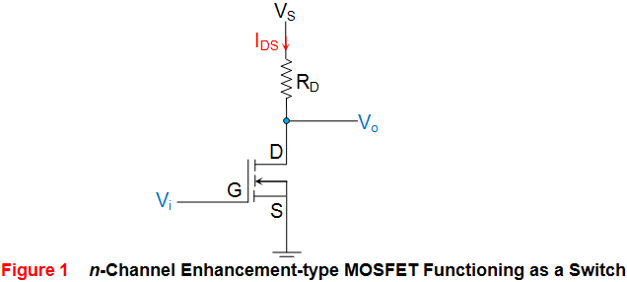

Now consider the case where Vi applied is 0V, which means the gate terminal of the MOSFET is left unbiased. As a result, the MOSFET will be OFF and operates in its cutoff region wherein it offers a high impedance path to the flow of current which makes the IDS almost equivalent to zero. As a result, even the voltage drop across RD will become zero due to which the output voltage Vo will become almost equal to VS. Next, consider the case where the input voltage Vi applied is greater than the threshold voltage VT of the device. Under this condition, the MOSFET will start to conduct and if the VS provided is greater than the pinch-off voltage VP of the device (usually it will be so), then the MOSFET starts to operate in its saturation region. This further means that the device will offer low [resistance](https://www.electrical4u.com/electrical-resistance-and-laws-of-resistance/) path for the flow of constant IDS, almost acting like a short circuit. As a result, the output voltage will be pulled towards low voltage level, which will be ideally zero.

From the discussion presented, it is evident that the output voltage alters between VS and zero depending on whether the input provided is less than or greater than VT, respectively. Thus, it can be concluded that MOSFETs can be made to function as electronic switches when made to operate between cut-off and saturation operating regions. Similar to the case of n-channel enhancement type MOSFET, even n-channel depletion type MOSFETs can be used to perform switching action as shown by Figure 2. The behaviour of such a circuit is seen to be almost identical to that explained above except the fact that for cut-off, the gate voltage VG needs to be made negative and should be lesser than -VT.

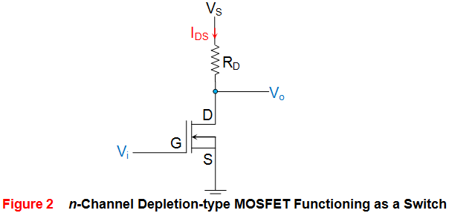 h 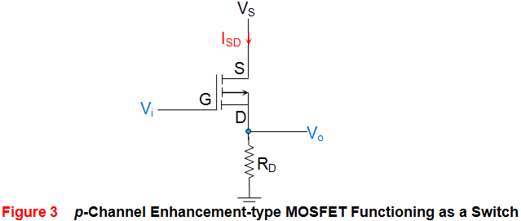

Next, Figure 3 shows the case wherein the p-channel enhancement **MOSFET is used as a switch**. Here it is seen that the supply voltage VS is applied at its source terminal (S) and the gate terminal is provided with the input voltage Vi while the drain terminal is grounded via the resistor RD. Further the output of the circuit Vo is obtained across RD, from the drain terminal of the MOSFET. In the case of p-type devices the conduction current will be due to holes and will thus flow from source to drain ISD, and not from drain to source (IDS) as in the case of n-type devices. Now, let us assume that the input voltage which is nothing but the gate voltage VG of the MOSFET goes low. This causes the MOSFET to switch ON and to offer a low (almost negligible) resistance path to the current flow. As a result heavy current flows through the device which results in a large voltage drop across the resistor RD. This inturn results in the output which is almost equal to the supply voltage VS.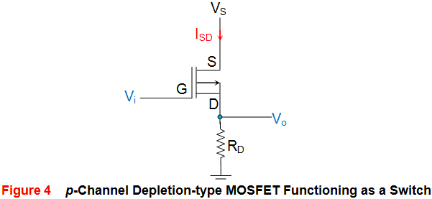

**PNEUMATIC SOLENOID VALVE**

Must Watch:

<https://www.youtube.com/watch?v=Vb0yov7UFy8> (for all working and concepts)

GO through these tutorials for arduino interfacing with the solenoid valve:

<https://www.bc-robotics.com/tutorials/controlling-a-solenoid-valve-with-a> rduino/ (code is similar that to blink LED)

**Pneumatic Actuated**

Pneumatic actuation refers to a valve being tripped through the use of compressed air (gas). At a particular point in an industrial or manufacturing process, compressed air is released, causing a valve to open or close. The combination of solenoids and pneumatics is twofold. Solenoid valves are used in pneumatic processes and solenoid valves and pneumatic valves are used in combination. The combined valve is called a piloted valve. The larger solenoid valve is triggered by the smaller pneumatic valve. The pneumatic valve can act as an air cylinder contained in a main valve. A pneumatic solenoid valve is also referred to as a compressed air pilot valve.

## Types of Pneumatic Solenoid Valves

Valves can be designated as internally piloted or externally piloted. The valves can further be categorized by the number of connections or paths for flow they contain. Externally piloted valves use an external source of air pressure. Internally piloted use an internal source of air pressure. Two-way piloted valves can be used in dust collector systems. An internally driven pilot valve with four-way connections are generally found in pneumatic operations and are used to move double action cylinders. Pneumatic solenoid valves can be designed as stackable.

### How is a solenoid operated valve being made?

## THERE ARE 5 MAIN PARAMETERS TO CONSIDER WHEN SELECTING A VALVE:

* Cv
* media compatibility
* pressure
* temperature
* process fitting

Solenoid valve is a control units which, when electrically energized or de-energized, either shut off or allow fluid flow. The actuator takes the form of an electromagnet. When energized, a magnetic field builds up which pulls a plunger or pivoted armature against the action of a spring. When de-energized, the plunger or pivoted armature is returned to its original position by the spring action. 

### How does a solenoid valve operate?

To the mode of actuation, a distinction is made between direct- valves, internally piloted valves, and externally piloted valves. A further distinguishing feature is the number of port connections or the number of flow paths ("ways"). 

### Direct-acting solenoid valve

With a direct-acting solenoid valve, the seat seal is attached to the solenoid core. In the de-energized condition, a seat orifice is closed, which opens when the valve is energized. 

### Direct-acting 2-way solenoid valve

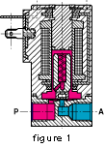Two-way solenoid operated valves are shut-off valves with one inlet port and one outlet port (Fig. 1). In the de-energized condition, the core spring, assisted by the fluid pressure, holds the valve seal on the valve seat to shut off the flow. When energized, the core and seal are pulled into the solenoid coil and the valve opens. The electro-magnetic force is greater than the combined spring force and the static and dynamic pressure forces of the medium.

### Direct-acting 3-way solenoid valve operation

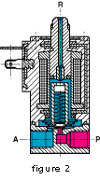Three-way solenoid operated valves have three port connections and two valve seats. One valve seal always remains open and the other closed in the de-energized mode. When the coil is energized, the mode reverses. The 3-way solenoid valve shown in Fig. 2 is designed with a plunger type core. Various valve operations can be obtained according to how the fluid medium is connected to the working ports in Fig. 2. The fluid pressure builds up under the valve seat. With the solenoid coil de-energized, a conical spring holds the lower core seal tightly against the valve seat and shuts off the fluid flow. Port A is exhausted through R. When the coil is energized the core is pulled in, the valve seat at Port R is sealed off by the spring-loaded upper core seal. The fluid medium now flows from P to A. 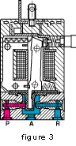Unlike the versions with plunger-type cores, pivoted-armature valves have all port connections in the valve body. An isolating diaphragm ensures that the fluid medium does not come into contact with the solenoid coil chamber. Pivoted-armature valves can be used to obtain any 3-way valve operation. The basic design principle is shown in Fig. 3. Pivoted-armature valves are provided with manual override as a standard feature. 

### Internally piloted solenoid valve

With direct-acting valves, the static pressure forces increase with increasing orifice diameter which means that the magnetic forces, required to overcome the pressure forces, become correspondingly larger. Internally piloted solenoid valves are therefore employed for switching higher pressures in conjunction with larger orifice sizes; in this case, the differential fluid pressure performs the main work in opening and closing the valve. 

### Internally piloted 2-way solenoid valve

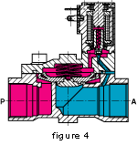Internally piloted solenoid valves are fitted with either a 2- or 3-way solenoid valve. A diaphragm or a piston provides the seal for the main valve seat. The operation of such a valve is indicated in Fig. 4. When the pilot valve is closed, the fluid pressure builds up on both sides of the diaphragm via a bleed orifice. As long as there is a pressure differential between the inlet and outlet ports, a shut-off force is available by virtue of the larger effective area on the top of the diaphragm. When the pilot valve is opened, the pressure is relieved from the upper side of the diaphragm. The greater effective net pressure force from below now raises the diaphragm and opens the valve. In general, internally piloted valves require a minimum pressure differential to ensure satisfactory opening and closing. Omega also offers internally piloted valves, designed with a coupled core and diaphragm that operate at zero pressure differential (Fig. 5). 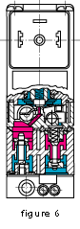

### Internally piloted multi-way solenoid valve

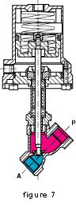Internally piloted 4-way solenoid valves are used mainly in hydraulic and pneumatic applications to actuate double-acting cylinders. These valves have four port connections: a pressure inlet P, two cylinder port connections A and B, and one exhaust port connection R. An internally piloted 4/2-way poppet valve is shown in Fig. 6. When de-energized, the pilot valve opens at the connection from the pressure inlet to the pilot channel. Both poppets in the main valve are now pressurized and switch over. Now port connection P is connected to A, and B can exhaust via a second restrictor through R. 

### Externally piloted solenoid valve

With these types an independent pilot medium is used to actuate the valve. Fig. 7 shows a piston-operated angle-seat valve with closure spring. In the unpressurized condition, the valve seat is closed. A 3-way solenoid valve, which can be mounted on the actuator, controls the independent pilot medium. When the solenoid operated valve is energized, the piston is raised against the action of the spring and the valve opens. A normally-open valve version can be obtained if the spring is placed on the opposite side of the actuator piston. In these cases, the independent pilot medium is connected to the top of the actuator. Double-acting versions controlled by 4/2-way valves do not contain any spring. 

**PULL UP AND PULL DOWN RESISTOR**

For Concepts:

<https://www.youtube.com/watch?v=wxjerCHCEMg> (easy and understandable)

A microcontroller in any [embedded system](https://www.elprocus.com/real-time-applications-of-embedded-systems/) utilizes I/O signals to communicate with the external devices. The simplest form of I/O  is usually stated to as GPIO(General Purpose Input/Output). When the GPIO voltage level is low, then it is in high or high impedance state, then the pull up and pull-down resistors are used to ensure GPIO which is always in a valid state.Usually, the GPIO is arranged on a [microcontroller](https://www.elprocus.com/pin-diagram-of-8051-microcontroller/) as I/O. As an input, the microcontroller pin  can take one of these states: high, low and floating or high impedance. When an i/p is driven above the i/p is high threshold, it is a logic one.When the I/P is driven below the I/P, which is low threshold, the input is logic 0. When in a floating or high impedance state, the I/P level is not constantly high nor low. To ensure the values of an I/P is always in a known state, pull up and pull-down resistors are used.The main function of pull-up and pull-down resistors is that the pull up resistor pulls the signal to high state unless it

is driven low; and, a pull-down resistor pulls the signal to low state unless it is driven high.

**PULL UP RESISTOR**

Pull-up resistors are simple fixed value resistors, that are connected between the voltage supply and the particular pin. These resistors are used in [digital logic circuits](https://www.elprocus.com/different-types-of-digital-logic-circuits/) to ensure a logic level at a pin, which results in state wherein the input/output voltage is nonexistence driving signal. Digital logic circuits consist of three states like  high, low and floating or high impedance. When the pin is not pulled to a lower or a high logic level, then the high impedance state occurs. These resistors are used to solve the problem for the microcontroller by pulling the value to a high state, as seen in the figure. When the switch is open, the microcontrollers input would be floating and brought down only when the switch is closed. A typical pull-up resistor value is 4.7kilo Ohms, but can change depending on the application.

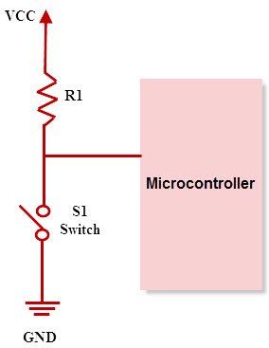

**Pull-Down Resistors**

As pull up resistors, Pull-down resistors also works in the same way. But, they pull the pin to a low value. Pull-down resistors are connected between a particular pin on a microcontroller and the ground terminal. An example of a pull down resistor is a digital circuit shown in the figure below. A switch is connected between the VCC and the microcontroller pin. When the switch is closed in the circuit, the input of the microcontroller is logic 1,but when the switch is open in a circuit, the pull down resistor pulls down the input voltage to the ground (logic 0 or logic low value). The pull down resistor should have a higher resistance than the impedance of the logic circuit.

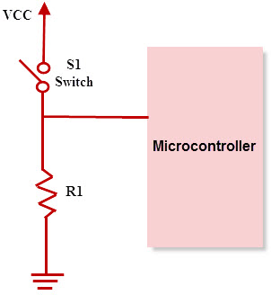

**Applications of Pull-Up and Pull-Down Resistors**

* Pull-up and pull-down resistors are frequently used in [interfacing devices](https://www.elprocus.com/types-interfacing-devices-applications-with-microcontroller/) like interfacing a switch to microcontroller.
* [Most of the microcontrollers](https://www.elprocus.com/microcontrollers-types-and-applications/) have inbuilt programmable pull up/pull down resistors.So Interfacing a switch with a microcontroller directly is possible.
* In general, pull up resistors are often used than pull down resistors, although some microcontroller families have both pull-up and pull-down resistors.
* These resistors are often used in [A/D converters](https://www.elprocus.com/analog-digital-converters/) to provide a controlled flow of current into a resistive sensor
* Pull-up and pull-down resistors are used in I2C protocol bus, wherein the pull-up resistors are used to allow a single pin to act as an I/P or O/P.
* When it is not connected to a I2C protocol bus, the pin floats in a high impedance state. Pull down resistors are also used for outputs to afford a known O/P

STACK EXCHANGE

**Q) Should I pull my single-throw inputs up or down? When is pulling down preferred over pulling up and vice versa?**

The answer depends on what you want the "default" configuration to be. For example, say you have a down-stream N-channel MOSFET, and you want it default off. Then you would use a pull-down resistor to ensure this behavior if the input becomes high impedance.

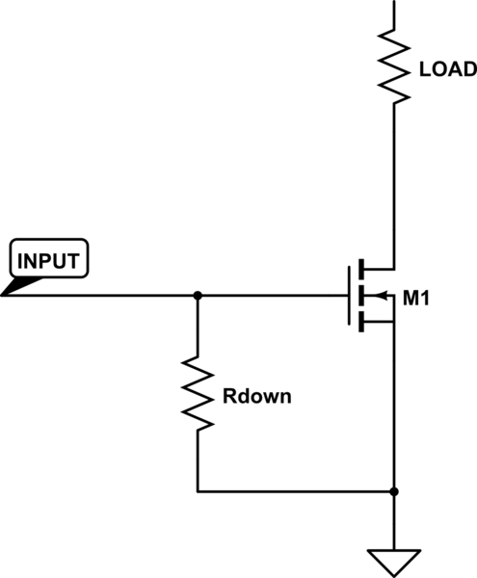

[simulate this circuit](https://electronics.stackexchange.com/plugins/schematics?image=http%3a%2f%2fi.stack.imgur.com%2fYwcFa.png)– Schematic created using[CircuitLab](https://www.circuitlab.com/)

On the other hand, suppose you have an upstream P-channel MOSFET, and want it default off. This time a pull up resistor is required to create this behavior.

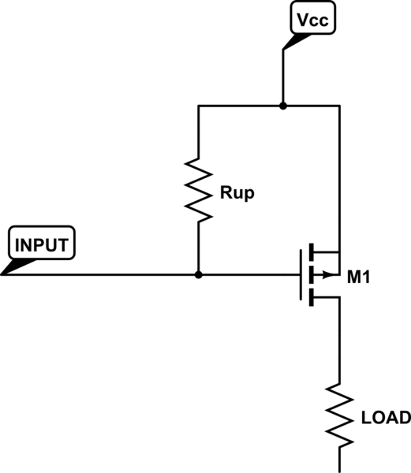

[simulate this circuit](https://electronics.stackexchange.com/plugins/schematics?image=http%3a%2f%2fi.stack.imgur.com%2fMpjhd.png)

There's also the alternative case where you want a device to be default-on, in which case the above two cases would be reversed (pull-up for the N-channel MOSFET, pull-down for the P-channel MOSFET).

A few other considerations:

1. I2C lines specify pull-up resistors because devices are "expected" to have an open-drain to ground, and thus need some way to raise the line potential.
2. Analog comparators are usually configured as open-drain devices, and thus also need pull up resistors to get a high potential output.
3. You may draw more current using pullup/pulldown resistors, depending on what's hooked to the input/output.
4. Either configuration could works equally well in your application (i.e. there's no significant advantage one way or the other).

... And any number of very application-specific reasons why one configuration may be preferred.

Answer 2

If you are working with an Arduino/ATmega328 you can use the [built in pull-up resistor](http://arduino.cc/en/Tutorial/DigitalPins).

There are 20K pullup resistors built into the Atmega chip that can be accessed from software. These built-in pullup resistors are accessed by setting the pinMode() as INPUT_PULLUP. This effectively inverts the behavior of the INPUT mode, where HIGH means the sensor is off, and LOW means the sensor is on.

The value of this pullup depends on the microcontroller used. On most AVR-based boards, the value is guaranteed to be between 20kΩ and 50kΩ. On the Arduino Due, it is between 50kΩ and 150kΩ. For the exact value, consult the datasheet of the microcontroller on your board.

When connecting a sensor to a pin configured with INPUT_PULLUP, the other end should be connected to ground. In the case of a simple switch, this causes the pin to read HIGH when the switch is open, and LOW when the switch is pressed.

The Raspberry Pi [has them as well](https://projects.drogon.net/raspberry-pi/wiringpi/special-pin-functions/).